Contents

**1.** **User manual** 2

**1.1** **Login** 2

**1.1.1** **Open Login Form** 2

**1.1.1** **Login** 2

**1.2** **Common** 3

**1.2.1** **View your profile** 3

**1.2.2** **Log-out** 3

**1.3** **Manager** 3

**1.3.1** **Manager Home Page** 3

**1.3.2** **Room Type Management Page** 4

**1.3.3** **Room Management Page** 6

**1.3.4** **Account Management Page** 9

**1.3.5** **My Information Page** 12

**1.4** **Receptionist** 15

**1.5** **Accountant** 15

# **User manual**

## **Login**

### **Open Login Form**

* At “Anh Duong” hotel home page, click on button “Đăng nhập”.

### **Login**

* Enter your account and password into “Tên đăng nhập” field and “Mật khẩu” field
* After you enter all your information, click on button “Đăng nhập”
* If you want to show password that you enter, click on “Hiện thị mật khẩu” option

## **Common**

### **View your profile**

* ****Click on your name

### **Log-out**

* Click on button “Đăng xuất”

## **Manager**

### **Manager Home Page**

* Click on “Quản Lý Loại Phòng” will open room type management page.
* Click on “Quản Lý Phòng” will open room management page.
* Click on “Quản Lý Tài Khoản” will open account management page.
* Click on “Thông tin của tôi” will open my profile page.

### **Room Type Management Page**

#### View Room Type (Update UI)

* + Select “Chọn kiểu phòng”
  + Click on button “Xem”

#### Edit Room Type

* When you select room type and click on button “Xem” you can edit:
  + “Loại phòng” field: edit room type.
  + “Giá” field: edit price
  + “Người lớn” field: edit number of adult
  + “Trẻ em” field: edit number of children
  + “Miêu tả” field: edit description
  + “Thiết bị” table: edit accessory
* Click on button “Thêm thiết bị”, accessory table will add one more row.
* Click on button “Xóa”, accessory table will delete the last row.
* Click on button “Lưu”, and accept your change then room type information will be updated.
* Click on button “Hủy Bỏ”, the page will back to manager home page.
* Click on button “Thêm mới” will open add room type page.

#### Add Room Type

* You can create new room type by input information into:
  + “Mã” field: create room type identity code
  + “Loại phòng” field: create room type name
  + “Giá” field: create room type price
  + “Người lớn” field: create number of adult
  + “Trẻ em” field: create number of children
  + “Miêu tả” field: create room type description
  + “Thiết bị” table: create room type accessory
* Click on button “Thêm thiết bị”, accessory table will add one more row.
* Click on button “Xóa”, accessory table will delete the last row.
* Click on button “Lưu”, new room type will be created.
* Click on button “Hủy bỏ”, page will back to room type list page

### **Room Management Page**

#### 1.3.3.1 View Room List

* You can search room by floor, searching words or both of them:
  + Click on “Tầng” selection will show you list of floor.
  + Input your searching words into “Tìm kiếm” field.
* Click on button “Tìm” will search the room base on your floor selection or searching words then show the result.
* Click on button “Danh sách” will list all room in the hotel.
* Click on “Tên phòng” that you want to view, page will show the detail of this room and you can edit the information.
* Click on button “Thêm mới” will show add room page.
* Click on button “Quay lại”, page will back to manager home page.

#### 1.3.3.2 Edit Room

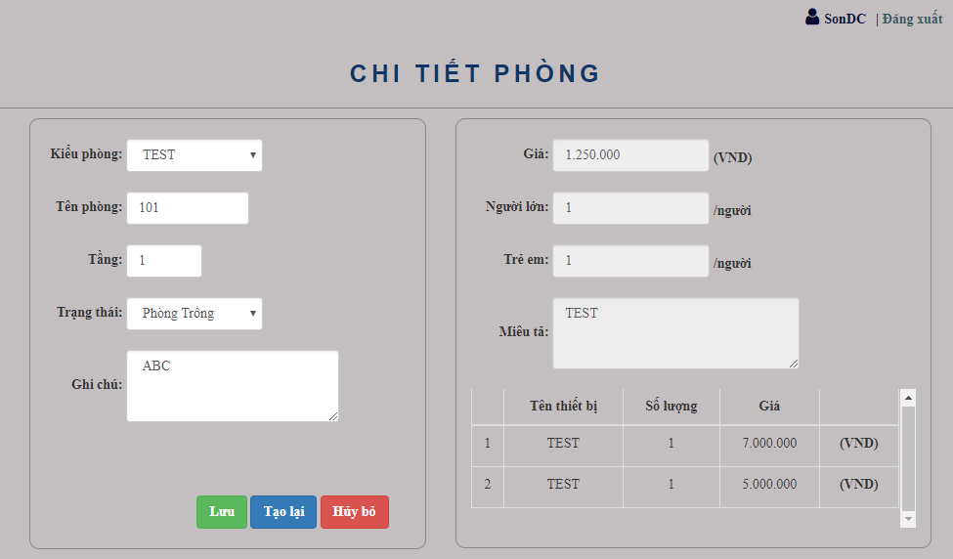

* At this page you can edit the information of room which you selected:
  + Select “Kiểu phòng”: show you all room type in the hotel.
  + “Tên phòng” field: edit room number of room name
  + “Tầng” field: edit room floor
  + “Trạng thái” field: edit room status
  + “Ghi chú” field: edit room note
* Click on button “Lưu” and accept your change then the room information will be updated.
* Click on button “Tạo lại” will discard all of your change.
* Click on button “Hủy Bỏ”, page will back to room list page.

#### 1.3.3.3 Add New Room

* You can create new room by input information below:
  + Select “Kiểu phòng”: show you all room type in the hotel.
  + “Mã” field: create room identity code
  + “Tên phòng” field: create room number of room name
  + “Tầng” field: create room floor
  + “Trạng thái” field: create room status
* Click on button “Thêm” then the new room will be created.
* Click on button “Tạo lại” will discard all of your change.
* Click on button “Hủy Bỏ”, page will back to room list page.

### **Account Management Page**

#### 1.3.4.1 View Account List

* You can search account by group of user, searching words, or both of them.
  + “Nhóm người dùng” selection: show you group of users.
  + Input your searching words into “Tìm kiếm” field.
* Click on button “Tìm” will search accounts base on your selection and searching words, then show the result.
* Click on button “Danh sách” will list all of accounts in your system.
* Click on button “Tên đăng nhâp” that you want to view, page will show the detail of this account.
* Click on button “Thêm mới” will open the add new account page.
* Click on button “Quay Lại”, page will back to manager home page.

#### 1.3.4.2 Edit Account

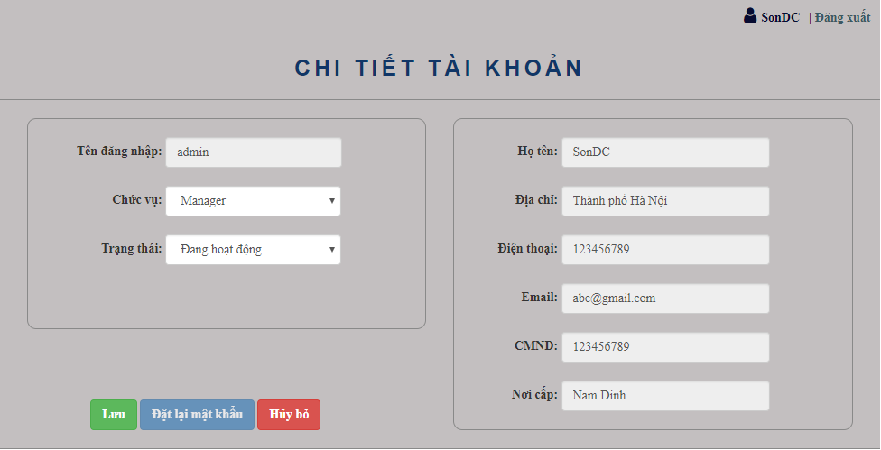

* You can edit group of user and status of this account
  + “Chức vụ” selection: edit the group of user
  + “Trạng thái” selection: edit status of this account
* Click on button “Lưu”, the user information will be updated.
* In the case, your account has been locked, click on button “Đặt lại mật khẩu”, this account’s password will be set to default password.
* Click on button “Hủy bỏ”, page will back to account list page

#### 1.3.4.3 Add New Account

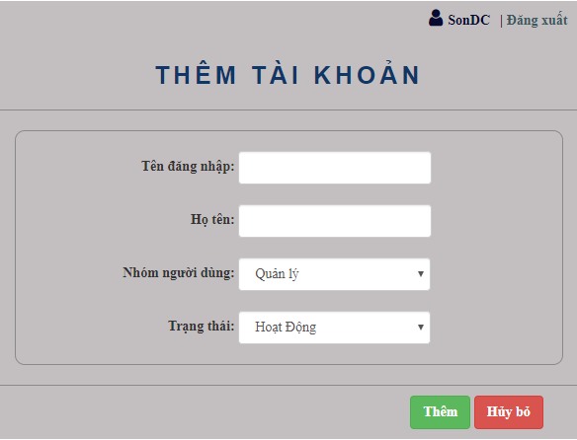

* “Tên đăng nhập” field: create new user name in order to login
* “Họ tên” field: create full name of owner.
* “Nhóm người dùng” Selection: create the group of user
* “Trạng thái” selection: create status of this account
* Click on button “Lưu” will create new account.
* Click on button “Hủy bỏ”, page will back to account list page

### **My Information Page**

#### View personal profile

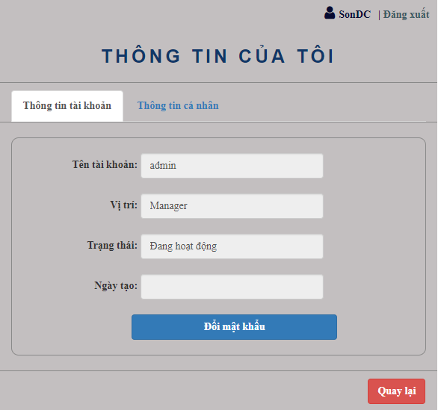

* **Click on button “Đổi mật khẩu” will open change password page.**
* **Click on tab “Thông tin cá nhân” will show your personal profile.**
* **Click on button “Quay lại”, page will back to manager home page.**

#### 1.3.5.2 Edit Personal File

* You can edit your personal profile such as your full name, address, …
  + “Họ tên” field: edit your full name.
  + “Địa chỉ” field: edit your address.
  + “CMND” field: edit your identity card.
  + “Nơi cấp” field: edit identity card location.
  + “Điện thoại” field: edit phone.
  + “Email” field: edit your email.
* Click on button “Lưu”: user information will be updated.
* Click on button “Quay lại” page will back to manager home page.

#### Change Password

* **“Mật khẩu cũ” field: input your old password.**
* **“Mật khẩu cũ” filed: input your new password.**
* **“Xác nhận mật khẩu”: input your confirmation password.**
* **Click on button “Thay đổi”, your password will be updated.**
* **Click on button “Quay lại”, page will back to my profile page.**

## **Receptionist**

## **Accountant**

#### 1.5.1 Accountant Home

* Click on button “Quản lý tiền thu” will show receptionist received money management page.
* Click on button “Thông tin của tôi” will show your personal profile page.

#### 1.5.2 Accountant List

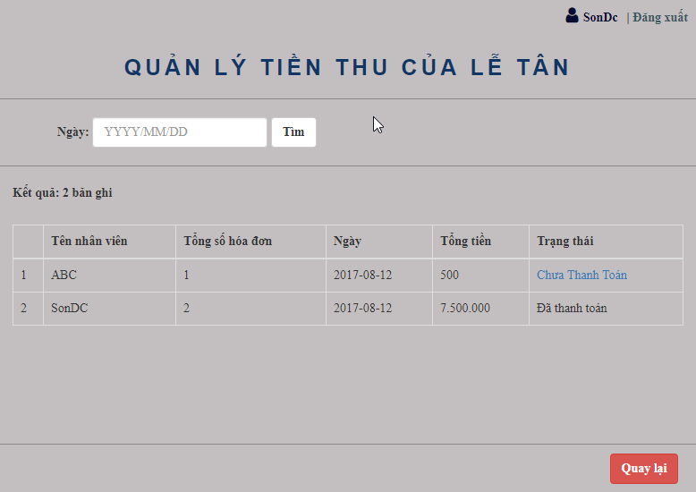

* + You can search accountant by select date and click on button “Tìm”
  + Click on button “Chưa thanh toán”, will show you update accountant page.
  + Click on button “Quay lại”, page will back to accountant home page

#### 1.5.3 Update Accountant

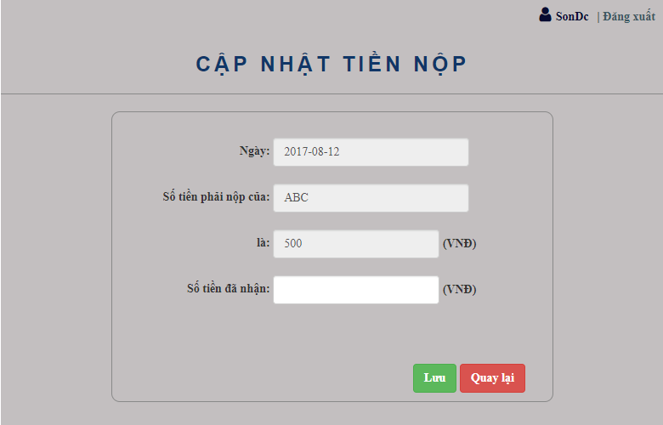

* “Số tiền đã nhận” field: edit total money that you receive,
* Click on button “Lưu” will update the information.
* Click on button “Quay lại”, page will back to accountant list page.